How to view the mount – details?

The most common cmd – findmnt

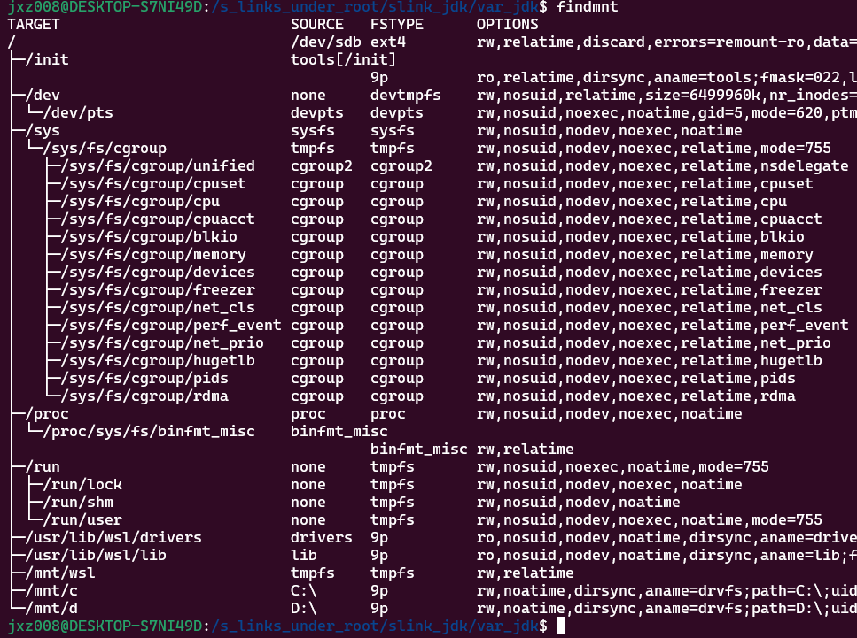

mount | grep '/mnt/wsl'

